Queries are often executed in parallel with multiple workers. Parallel execution spreads the database over multiple resources. Resources include CPUs, GPUs, additional machines, disks, memory. Spreading the database over many resources allows it to:
- Deal with large data sets that don’t fit on a single machine/node
- Have higher performance due to parallel processing
- Have a higher level of redundancy/fault-tolerance

Parallel vs. Distributed Databases
- Parallel DBMS In a parallel DBMS, resources, or nodes, are physically close to each other. These nodes communicate over a high-speed interconnect. It is assumed that communication between resources is not only fast, but also cheap and reliable.
- Distributed DBMS In a distributed DBMS, resources may be far away from each other; this might mean the database spans racks or data centers in different parts of the world. As a result, resources communicate using a slower interconnect (often over a public network). Communication costs between nodes are higher and failures cannot be ignored.
Even though a database may be physically divided over multiple resources, it still appears as a single logical database instance to the application. Thus, a SQL query executed against a single-node DBMS should generate the same result on a parallel or distributed DBMS.

Process Models
A DBMS process model defines how the system supports concurrent requests from a multi-user application/environment. The DBMS is comprised of one or more workers that are responsible for executing tasks on behalf of the client and returning the results.
Types
process-per-worker
This approach assigns each worker a separate OS process, relying on the OS scheduler. A dispatcher assigns an application's database connection/request to a specific worker process, which executes the query directly.
This model reduces DBMS execution control and introduces higher overhead by depending on message passing or shared memory to maintain global data structures. However, a process crash won't disrupt the whole system because workers run in isolated OS contexts. To prevent separate processes from making redundant page copies and to maximize memory usage, shared memory is used for global structures.

Thread-per-worker
DBMS runs as a single process containing multiple worker threads (with or without a dispatcher thread). This grants the DBMS full control to manage its own task scheduling.
Advantages include lower context-switch overhead and eliminating the need to maintain a shared memory model. However, a single thread crash can kill the entire database process.

Inter-Query Parallelism
In inter-query parallelism, the DBMS executes different queries concurrently. Since multiple workers are running requests simultaneously, overall performance is improved. This increases throughput and reduces latency. Introduces race conditions
Intra-Query Parallelism
Executes a single query's operations concurrently using a producer/consumer structure to reduce long-running query latency. Operators run parallel tasks by either accessing centralized data structures or partitioning work across threads.
The DBMS optimizes performance by combining three non-mutually exclusive types: intra-operator, inter-operator, and bushy parallelism.
Intra-Operator Parallelism (Horizontal)
In intra-operator parallelism, the query plan’s operators are decomposed into independent fragments that perform the same function on different subsets of data.
DBMS inserts an exchange operator into the query plan to merge results from child operators. The exchange operator prevents the DBMS from executing operators above it in the plan until it receives all the data from the children.
3 types of exchange operators:
- Gather: Combine the results from multiple workers into a single output stream.
- Distribute: Split a single input stream into multiple output streams.
- Repartition: Reorganize multiple input streams across multiple output streams. This allows the DBMS to take inputs that are partitioned one way and then redistribute them in another way.
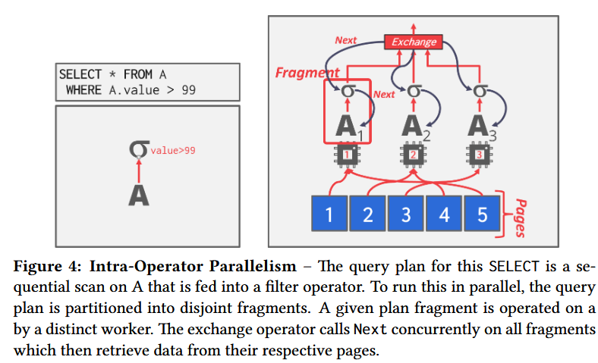

Inter-Operator Parallelism (Vertical)
In inter-operator parallelism, the DBMS overlaps operators in order to pipeline data from one stage to the next without materialization.
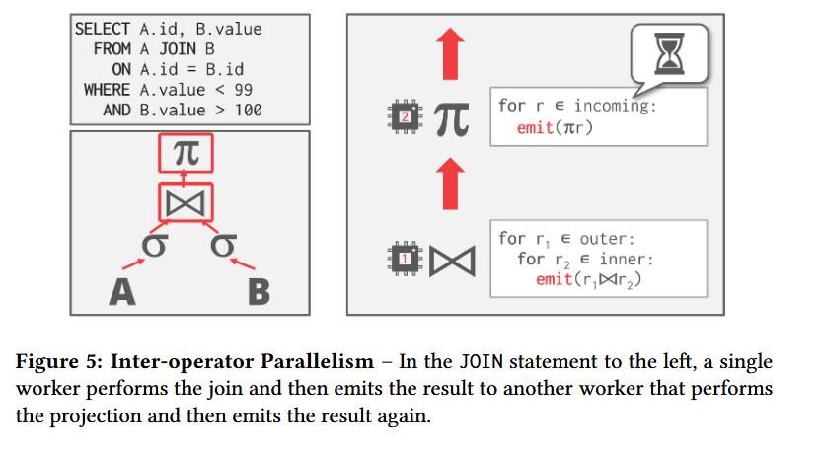
Bushy Parallelism
Bushy parallelism is a hybrid of intra-operator and inter-operator parallelism where workers execute multiple operators from different segments of the query plan at the same time. DBMS still uses exchange operators to combine intermediate results from these segments.
